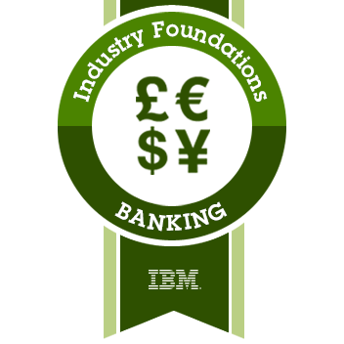

This badge was issued to [MEHMET CAMBAZ](https://www.youracclaim.com/users/mehmet-cambaz) on 31 August 2017.

<https://www.youracclaim.com/badges/dbcf4cd7-44ec-4006-8586-5a33b14aac42>